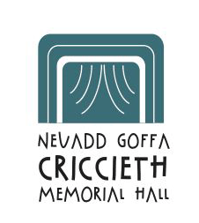
NEUADD GOFFA CRICCIETH MEMORIAL HALL

Elusen Cofrestredig / Registered Charity : 511623

CYFARFOD BLYNYDDOL / ANNUAL GENERAL MEETING

Mae pwyllgor rheoli’r neuadd yn eich hysbysu y cynhelir Cyfarfod Blynyddol y Neuadd Goffa ar Ddydd Llun, Medi 5ed 2022 am 7 yh yn y brif neuadd. Mae croeso cynnes i bawb.

The hall committee wishes to give notice that the Annual General Meeting of the Memorial Hall will take place on Monday 5th September 2022 at 7pm in the main hall.
Members of the public are invited to attend.

AGENDA

1. Ymddiheuriadau / Apologies
2. Derbyn cofnodion blaenorol y CB / Acceptance of previous AGM minutes
3. Adroddiad y Cadeirydd / Chairman's Report
4. Adroddiad y Trysorydd / Treasurer's Report
5. Rhestr o’r aelodau a enwebwyd / List of nominated members
6. Ethol aelodau’r pwyllgor / Election of committee members
7. Unrhyw fater arall / AOB

